E-LEARNING WEBSITE DEVELOPMENT AND DIGITAL MARKETING IMPLEMENTATION
PROJECT REPORT
Submitted By:
Prashant Upadhyay
Project Title:
E-Learning Website Development and Digital Marketing Implementation
Technologies Used:
WordPress, Elementor, Astra Theme, Tutor LMS, Rank Math SEO, Google Search Console, Google Ads
Submission Date:
August 2026
TABLE OF CONTENTS
• Introduction
• Project Objectives
• Project Overview
• Tools and Technologies Used
• Website Structure
• Website Development
• Website Pages
• Website Screenshots
• SEO Implementation
• Google Search Console
• Google Ads Campaign
• Internal and External Linking
• Project Documentation
• Challenges and Solutions
• Learning Outcomes
• Project Links
• Conclusion

INTRODUCTION

The E-learning Website Development and Digital Marketing Implementation project was developed to create a user-friendly online learning platform where students and learners can explore different courses and develop valuable skills.
The website was developed using WordPress and designed using Elementor. The Astra Theme was used to provide the basic website structure and appearance. Tutor LMS was used for managing online courses and creating the course enrollment structure.
Along with website development, the project focused on implementing basic digital marketing and Search Engine Optimization strategies. Rank Math SEO was used to optimize website pages with focus keywords, SEO titles, meta descriptions, image alt text, internal links, and other on-page SEO elements.
Google Search Console was used to understand website indexing, sitemap submission, URL inspection, and search engine visibility. Google Ads was also explored to create a paid advertising campaign for promoting the Digital Marketing Course.
The main purpose of the project was to combine website development, online course management, SEO, search engine indexing, and paid advertising into one practical E-learning project.
PROJECT OBJECTIVES
The main objectives of the project were:
- To create a professional E-learning website.
- To design website pages using WordPress and Elementor.
- To create a simple and user-friendly website navigation system.
- To add and organize online courses using Tutor LMS.
- To create an appropriate course enrollment flow.
- To introduce different course categories.
- To create an Instructors page for course teachers.
- To create an educational Blog section.
- To optimize website pages using Rank Math SEO.
- To select appropriate focus keywords for website pages.
- To create SEO-friendly titles and descriptions.
- To add descriptive image alt text.
- To implement internal linking between important pages.
- To understand the use of relevant external links.
- To use Google Search Console for sitemap and indexing monitoring.
- To understand Google Ads campaign creation.
- To create keywords, headlines, descriptions, and sitelinks for advertising.
- To gain practical knowledge of digital marketing and website development.
PROJECT OVERVIEW
The project focuses on creating an E-learning website that provides online courses and educational resources.
The main website pages include:
- Home
- About Us
- Courses
- Instructors
- Blog
- Contact Us
- Login/Register
- Individual Course Pages
The website was designed to make it easy for visitors to discover courses, learn about instructors, read educational content, and contact the platform.
The project also included SEO optimization and digital advertising activities to improve the understanding of how an E-learning website can attract organic and paid visitors.
TOOLS AND TECHNOLOGIES USED
Tool/Technology | Purpose
WordPress | Website development and content management
Elementor | Website page design
Astra Theme | Website theme and layout
Tutor LMS | Course and enrollment management
Rank Math SEO | SEO optimization
Google Search Console | Website indexing and search monitoring
Google Ads | Paid advertising
Canva | Creating/editing visual content
GitHub | Project repository and documentation

WordPress
WordPress was used as the main Content Management System for developing the website.

Elementor
Elementor was used to create and customize website pages, sections, headings, buttons, images, and layouts.

Tutor LMS
Tutor LMS was used to organize online courses and create the course enrollment structure.

Rank Math SEO
Rank Math was used for on-page SEO optimization, including focus keywords, SEO titles, meta descriptions, image alt text, and internal linking.
WEBSITE STRUCTURE
The website was organized using the following structure:
Home
│
├── About Us
│
├── Courses
│ ├── Digital Marketing
│ ├── Programming
│ ├── Graphic Design
│ └── Other Courses
│
├── Instructors
│
├── Blog
│
└── Contact Us
Course Enrollment Structure
Home
↓
Courses
↓
Individual Course
↓
Enroll Now
↓
Login/Register
↓
Enrollment/Checkout
↓
My Account/Course

The Enroll Now button should begin the appropriate Tutor LMS enrollment process rather than simply sending users to the Home or About Us page.
Website Screenshots

Screenshot 1 — Home Page
The Home page acts as the main entry point of the website. It provides an introduction to the E-learning platform and highlights courses, instructors, learning benefits, and other important information.
Primary Focus Keyword:
online courses
SEO Title:
Online Courses to Learn New Skills | Learn Hub
Meta Description:
Explore online courses and build valuable skills through flexible learning resources designed for students, beginners, and professionals.
Figure 1A: Home Page – Header and Hero Section

Figure 1B: Home Page – Courses and Why Choose Us Section


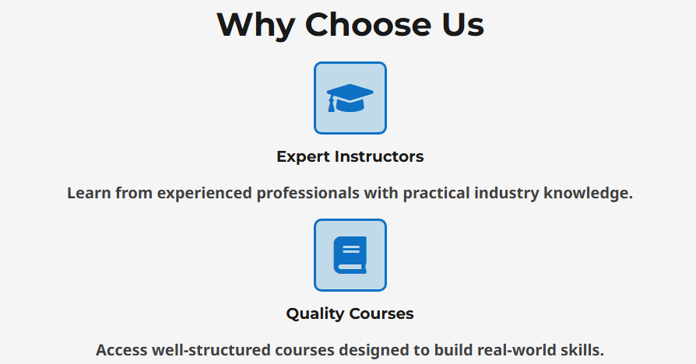
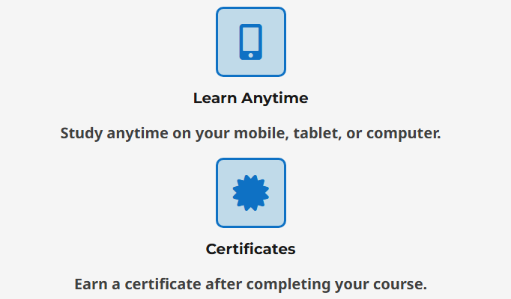
Figure 1C: Home Page – Instructors and Testimonials Section




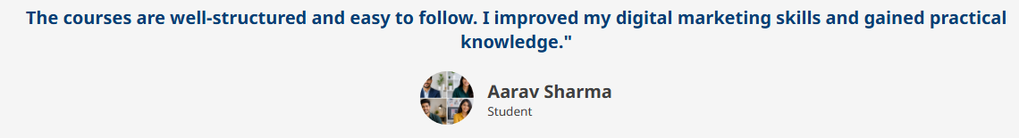

Figure 1D: Home Page – Blog and Footer Section



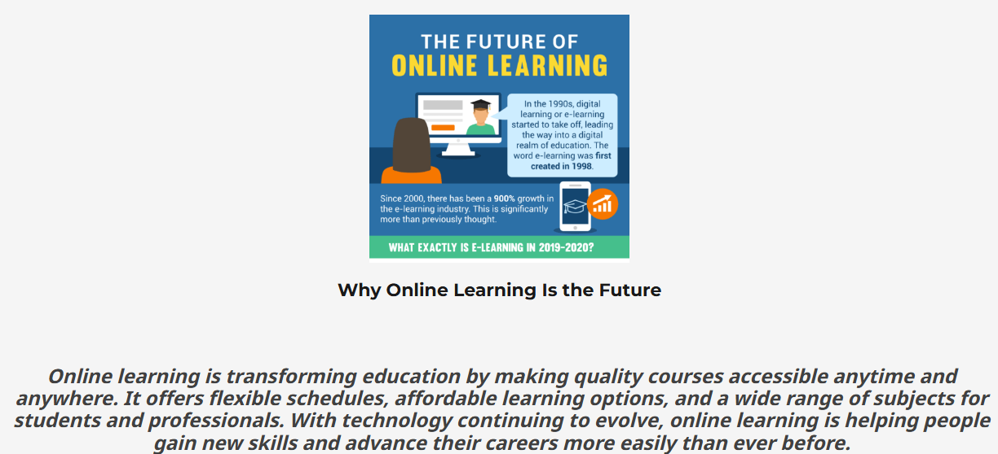

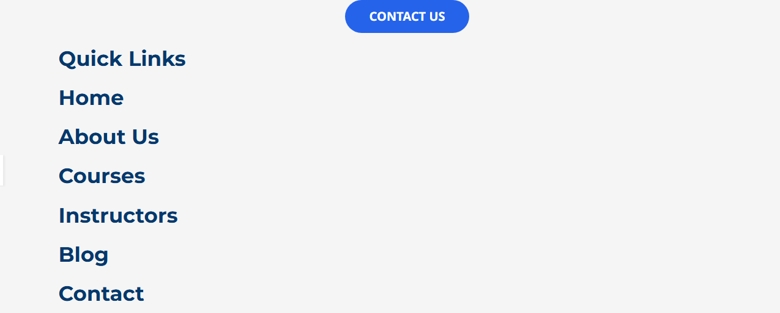

Screenshot 2 — About Us
The About Us page explains the purpose and goals of the E-learning platform. It provides information about the learning approach, course quality, and benefits offered to learners.
Primary Focus Keyword:
online learning platform
Figure 2A: About Us – Header & Introduction

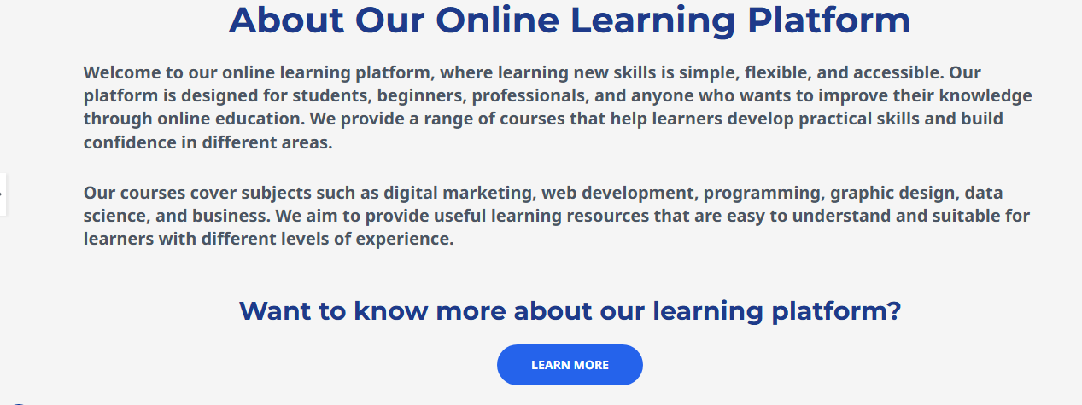
Figure 2B: About Us – Mission, Vision & Benefits

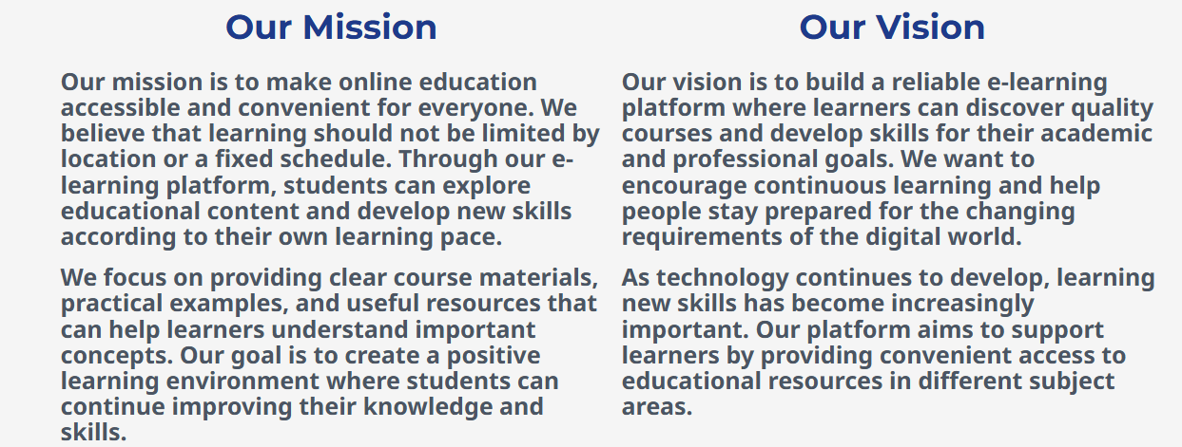
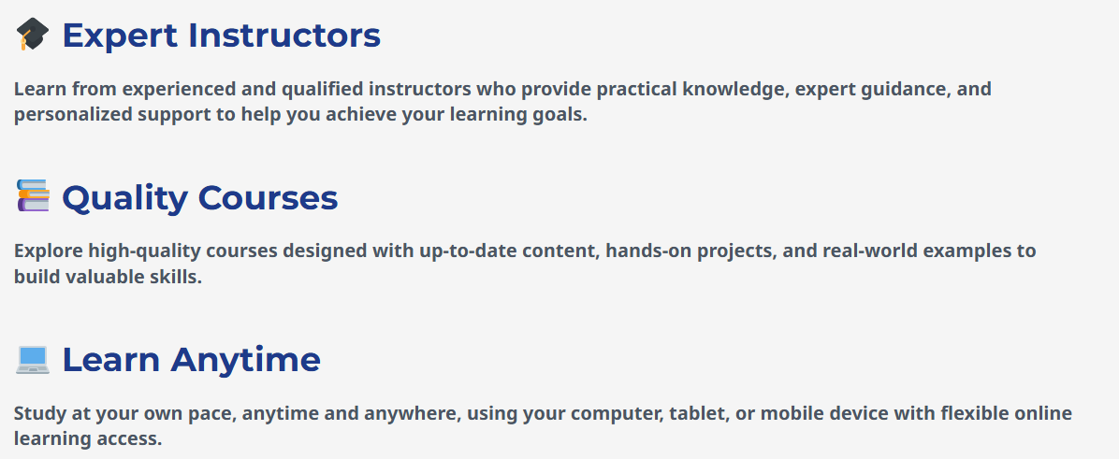
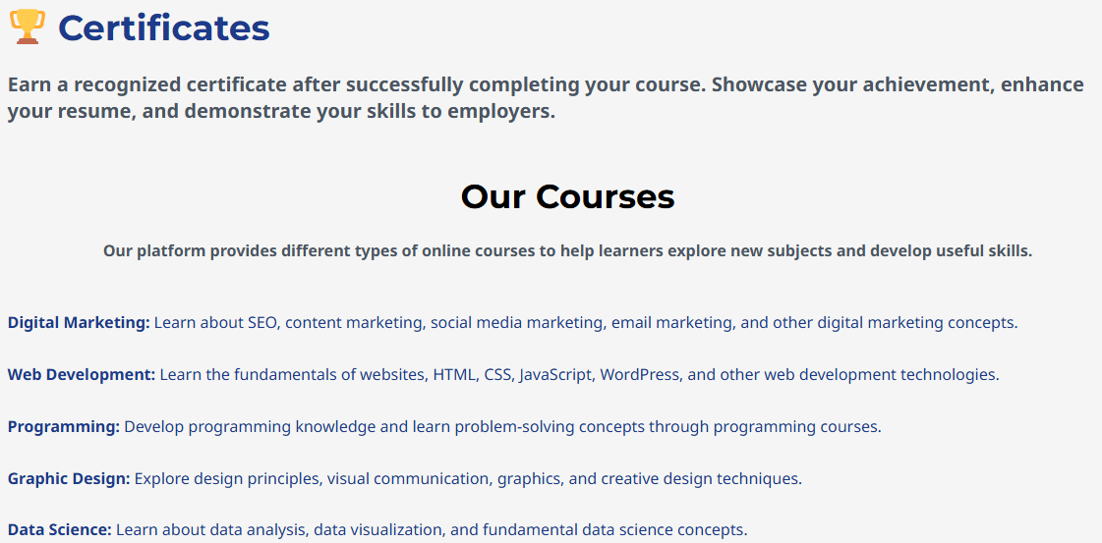
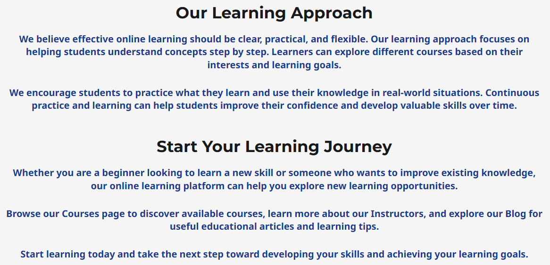

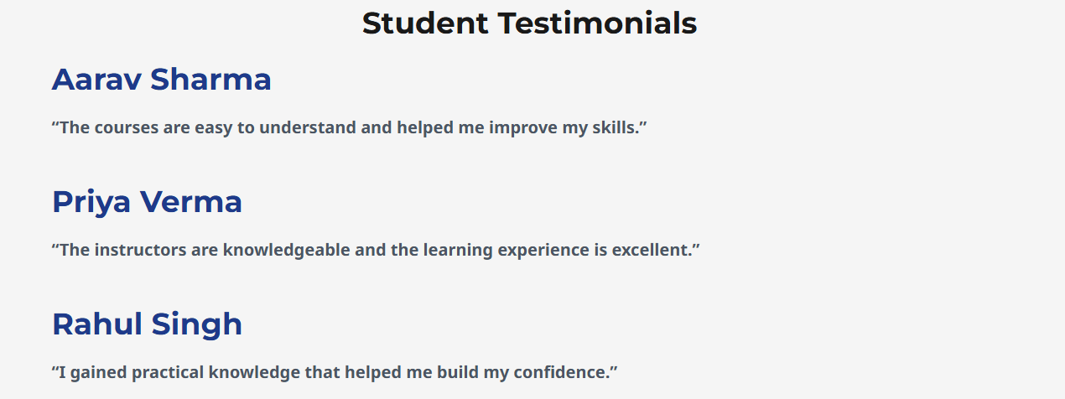
Figure 2C: About Us – CTA & Footer
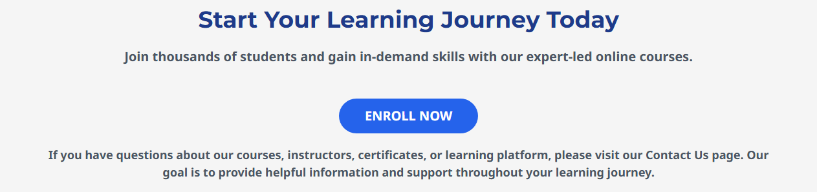
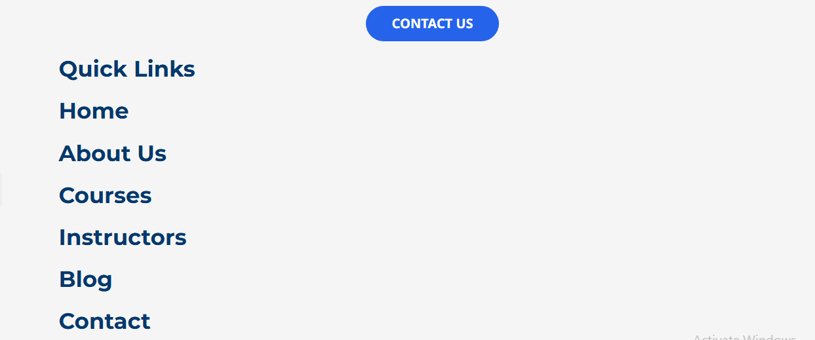
Screenshot 3 — Courses
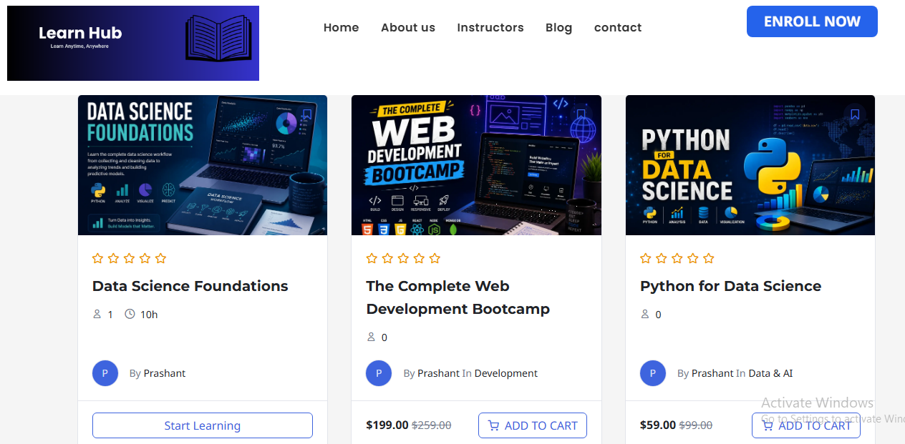
Screenshot 4 — Individual Course
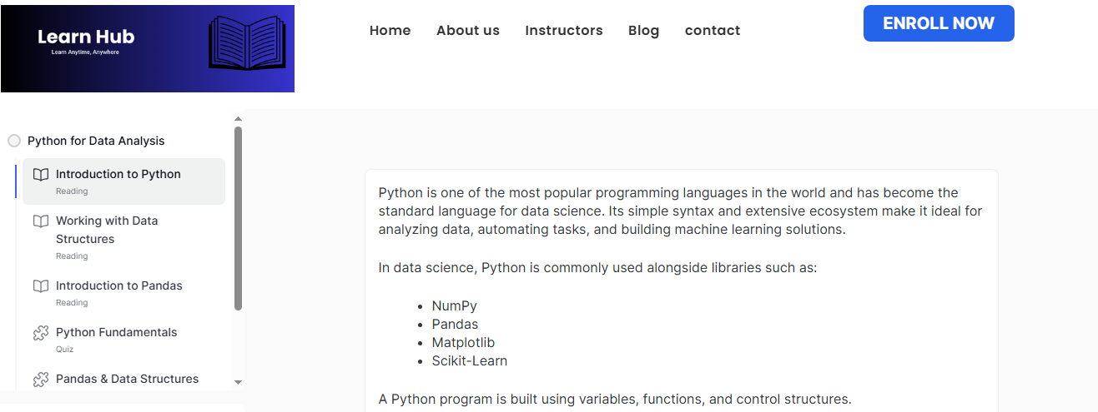
Screenshot 5 — Instructors

Screenshot 6 — Blog
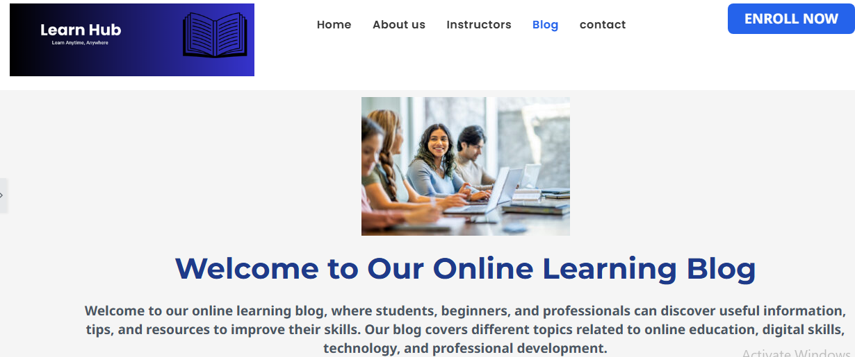
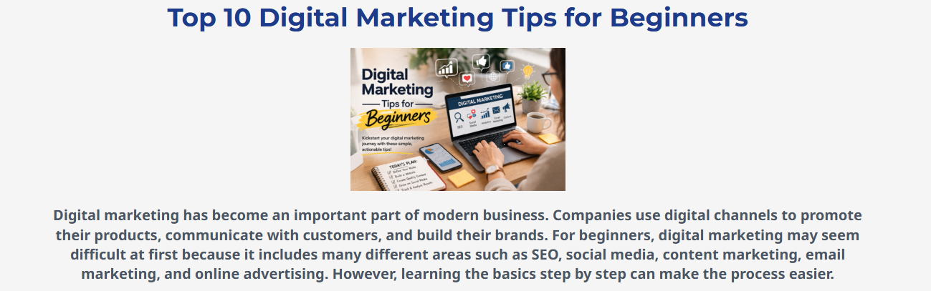
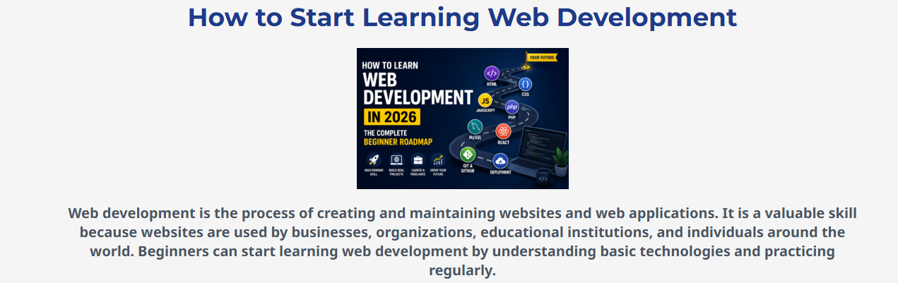

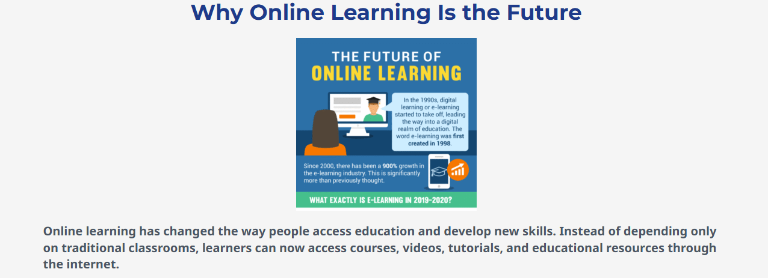


Screenshot 7 — Contact
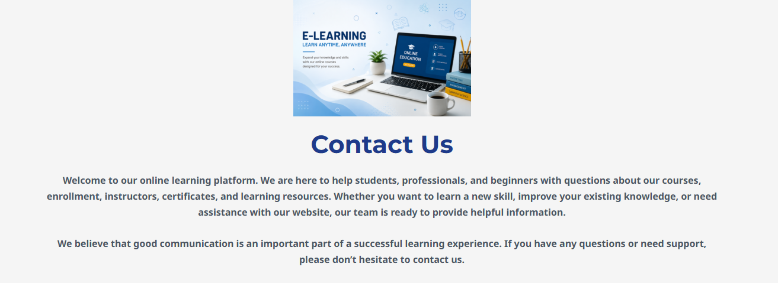
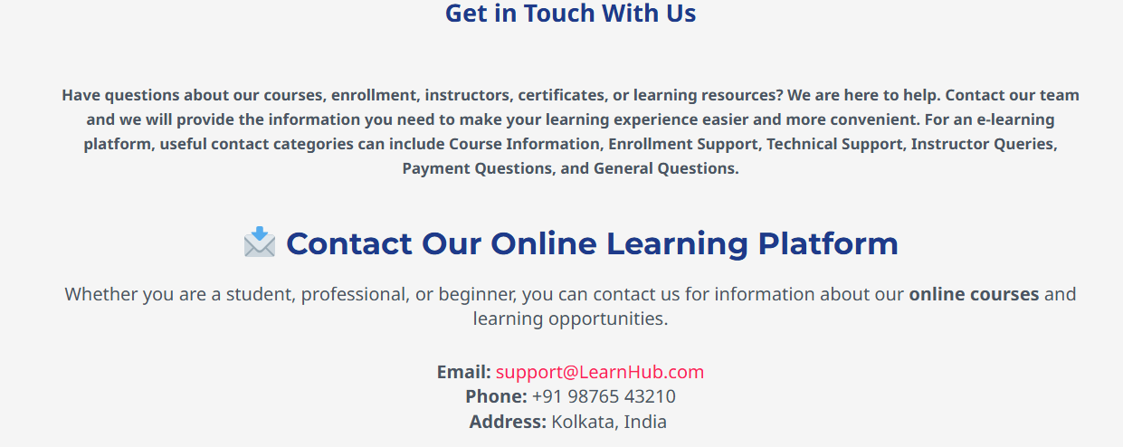
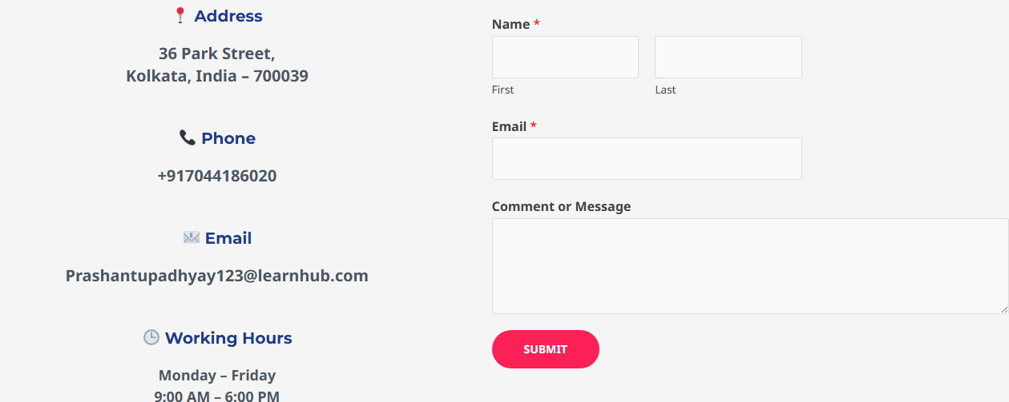
Screenshot 8 — Login/Register
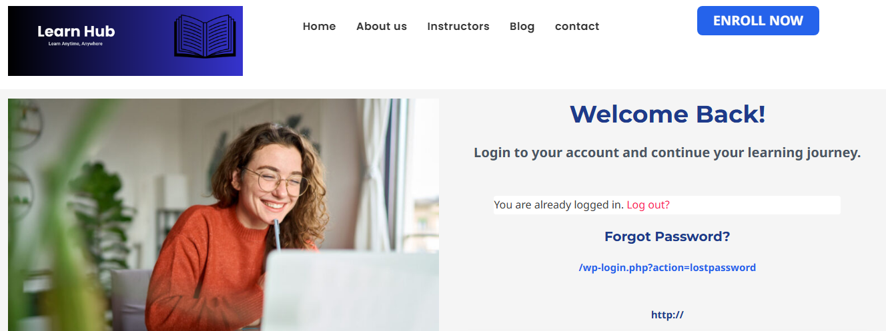
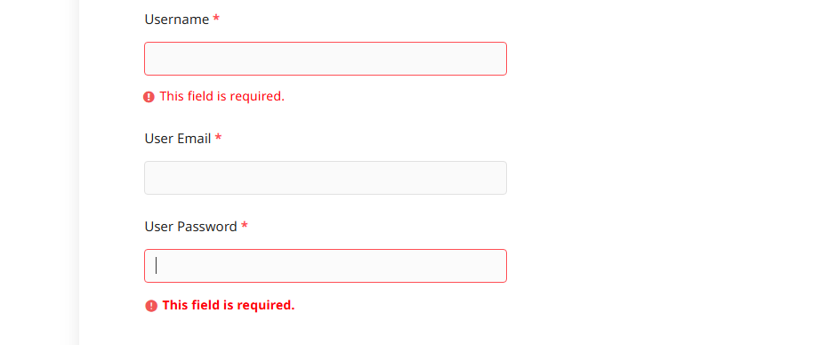
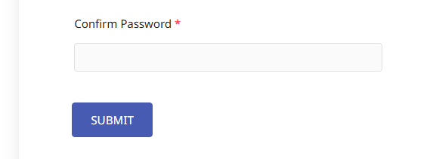
Screenshot 9 — My Account
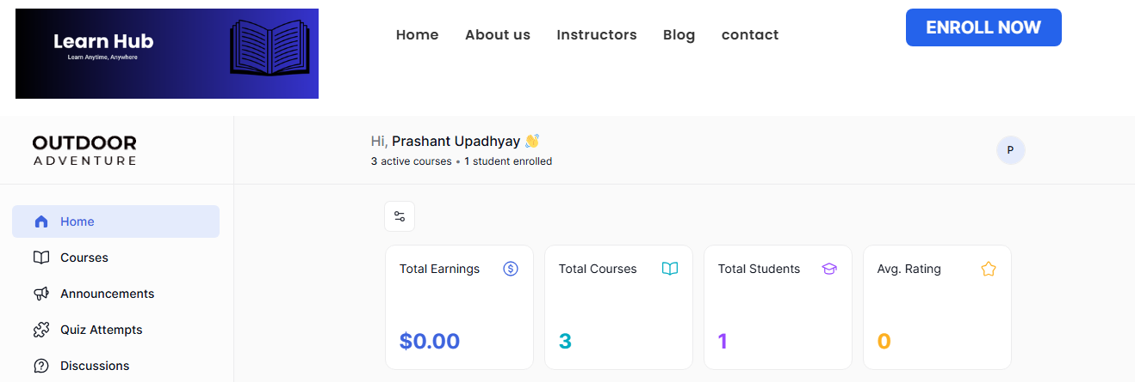

SEO Implementation
Rank Math SEO was used to optimize the important pages of the E-learning website. Focus keywords were selected for individual pages to match their content and search intent. SEO titles and meta descriptions were created to describe each page clearly.
Image alt text was added to relevant images, and internal links were created between important pages such as Home, Courses, Instructors, Blog, About Us, and Contact. The website sitemap was also configured and submitted through Google Search Console.
Rank Math recommendations were reviewed to improve content quality, keyword placement, headings, links, and other on-page SEO elements.
Focus keyphrase
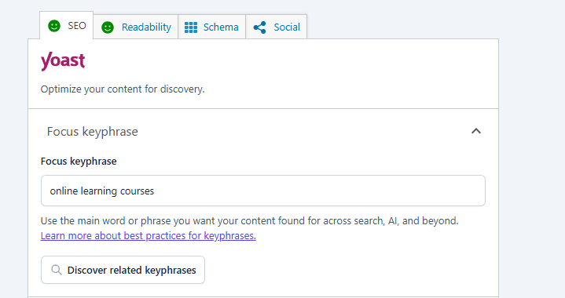
Seo Title
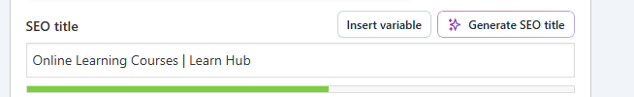
Meta description
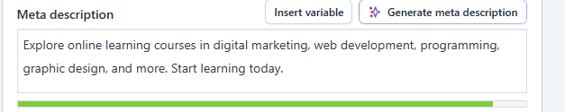
URL slug
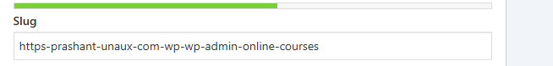
Image alt text
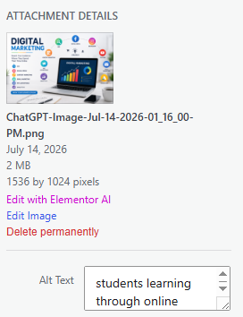
Internal links
Readability
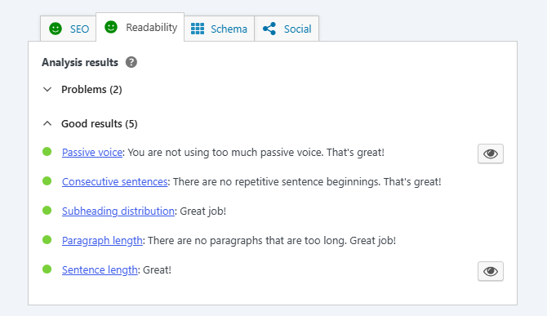
XML sitemap
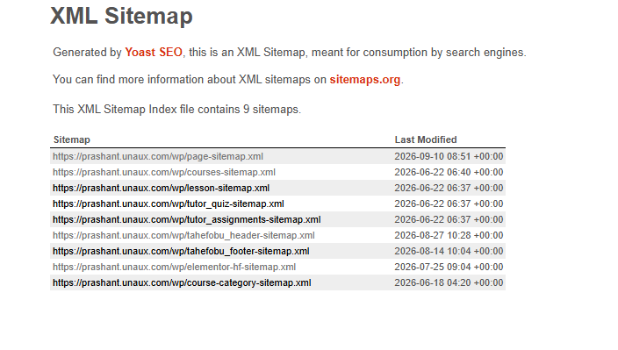
Google Search Console
Google Search Console (GSC) is a free tool provided by Google that helps website owners monitor, maintain, and improve their website’s presence in Google Search results. It provides useful information about how Google discovers, crawls, indexes, and displays website pages.
For my E-learning website project, Google Search Console was used to monitor the website's indexing and search performance. The website sitemap was submitted to Google Search Console so that Google could discover the available pages more easily.
Website Verification
Website verification is the process of proving ownership of a website in Google Search Console. I added my website to Google Search Console and completed the verification process. This allowed me to access important information about the website, including indexing status, search performance, and technical issues.
I verified the ownership of the e-learning website in Google Search Console. Website verification provided access to various SEO and search performance reports and allowed me to monitor how Google crawls and indexes the website.
Sitemap Submission
A sitemap contains the important URLs of a website and helps search engines discover its pages. I submitted the website's XML sitemap through Google Search Console.
I submitted the website's XML sitemap in Google Search Console to help Google discover and crawl the important pages of the e-learning website. The sitemap included URLs of important pages such as Home, About Us, Courses, Instructors, Blog, and Contact Us.
URL Inspection
The URL Inspection tool is used to check whether a particular webpage is known to Google and whether it can be indexed.
I used the URL Inspection tool in Google Search Console to check individual website URLs. It helped me identify the indexing status of webpages and verify whether Google could access and index the pages. Where necessary, I used the request indexing option for updated or newly created pages.
Indexing
Indexing means that Google has processed and stored a webpage so that it can potentially appear in Google Search results.
I monitored the indexing status of the website's pages through Google Search Console. I checked whether important webpages were indexed and identified any indexing-related issues. The identified issues were reviewed and corrective actions were taken where required.
Performance Monitoring
The Performance report in Google Search Console helps monitor how the website performs in Google Search.
You can mention these metrics:
- Clicks – Number of clicks from Google Search to the website.
- Impressions – Number of times the website appeared in search results.
- CTR (Click-Through Rate) – Percentage of impressions that resulted in clicks.
- Average Position – Average ranking position of the website's pages in search results.
I used the Performance report in Google Search Console to monitor the website's organic search performance. I analyzed clicks, impressions, click-through rate (CTR), and average position to understand the website's visibility in Google Search and identify opportunities for further SEO improvement.
Activity | Explanation
Website Verification | Verified ownership of the e-learning website in Google Search Console.
Sitemap Submission | Submitted the XML sitemap to help Google discover important website pages.
URL Inspection | Checked individual URLs to understand their Google indexing status.
Indexing | Monitored whether important webpages were indexed and identified indexing issues.
Performance Monitoring | Analyzed clicks, impressions, CTR, and average position to monitor organic search performance.

Search Console dashboard
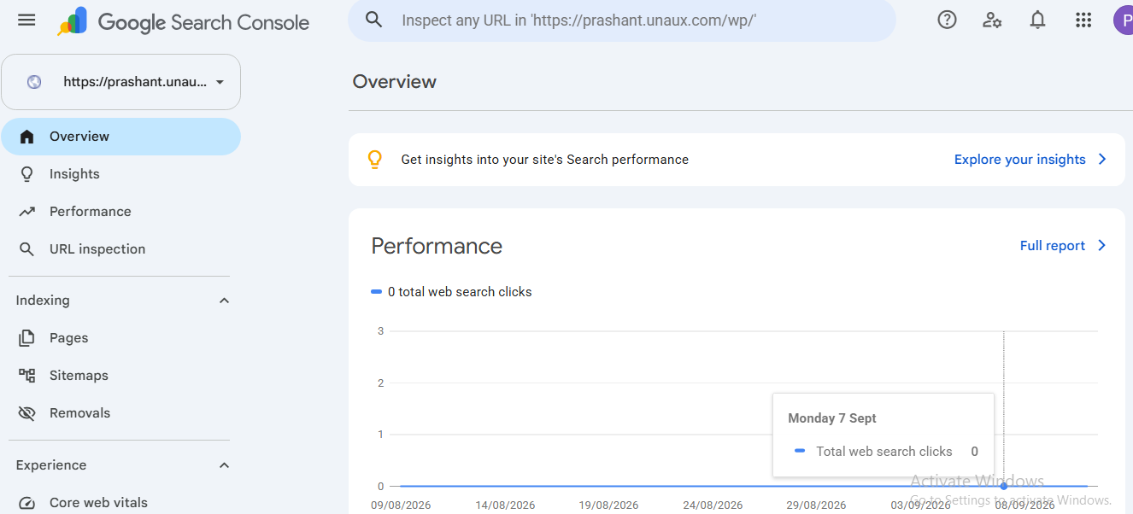
Sitemap
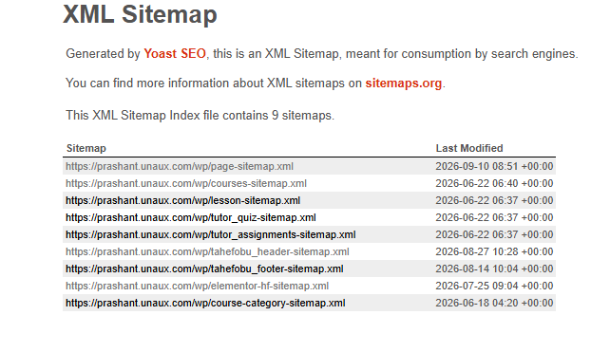
URL Inspection
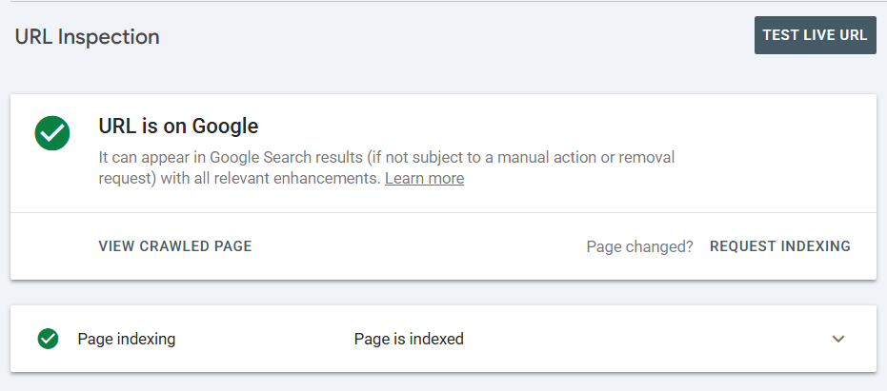
Page indexing
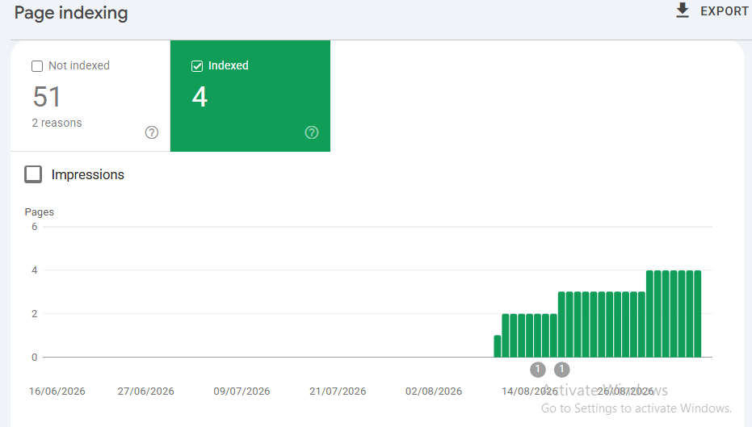
Performance report
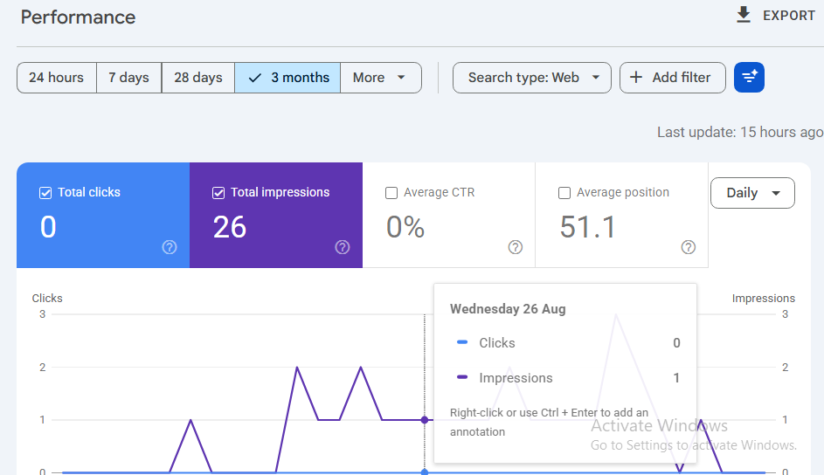

Google Ads Campaign
13.1 Campaign Objective
The objective of the Google Ads campaign was to promote online digital marketing courses and generate potential learners.
13.2 Target Audience
Mention:
- Students
- Fresh graduates
- Job seekers
- Working professionals
- People interested in digital marketing
13.3 Keywords
internet marketing course
online marketing programs
online marketing courses
online marketing classes
digital marketing training
online marketing certificate
digital marketing course
digital marketing classes
advanced digital marketing course
13.4 Ad Headlines
coding course for beginners
Digital Marketing Course
Digital Marketing for Beginner
Learn SEO & Digital Marketing
Digital marketing program
Master Digital Marketing Skill
digital marketing classes
13.5 Ad Descriptions
Learn digital marketing with our practical and beginner-friendly online course.
Build practical knowledge through structured lessons, real-world examples.
Upgrade your skills with expert-led online courses designed for students, beginners, and professionals. Learn anytime, anywhere.
Build career-ready skills through flexible online learning. Explore courses in Digital Marketing, Programming, Web Development, Design, and more.
13.6 Sitelink Assets
• Explore Courses
• Digital Marketing Course
• Our Instructors
• About Us
• Learning Blog
• Contact Us
13.7 Google Ads Screenshots
Campaign
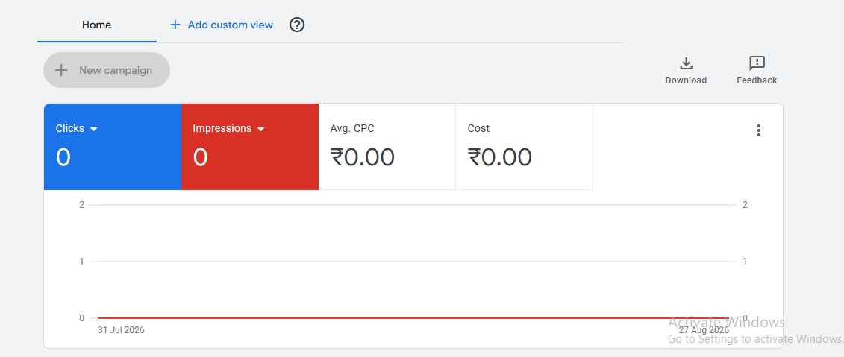
Keywords
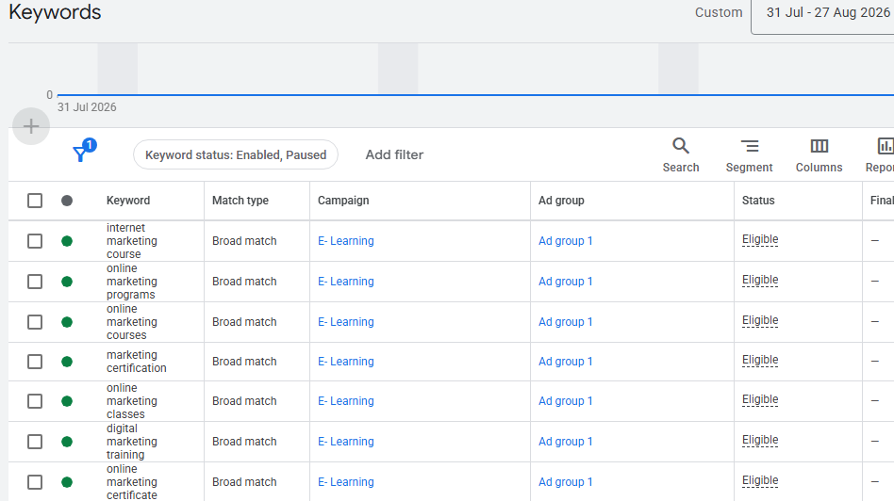

Insights
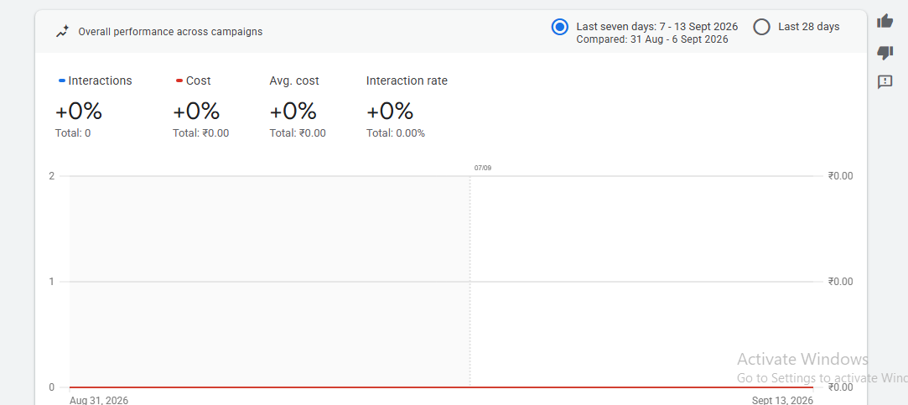

When and where ads showed
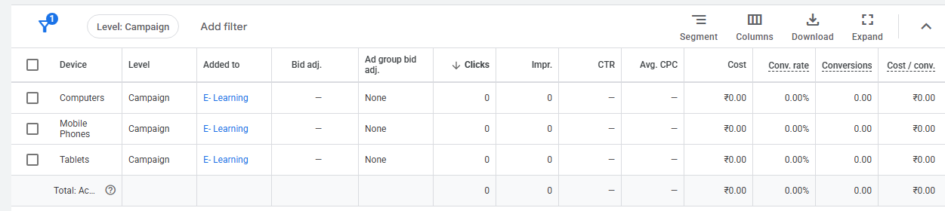
Content Marketing
Digital Marketing Tips for Beginners

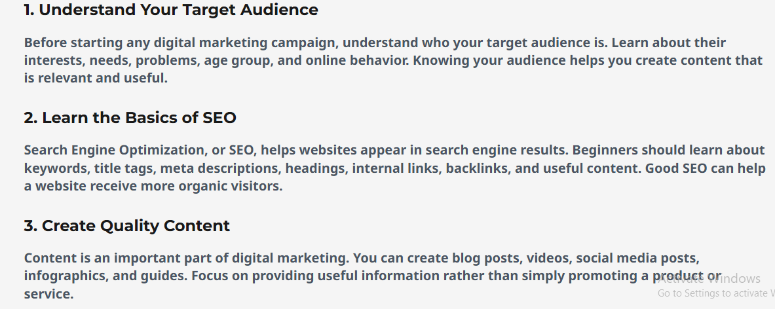
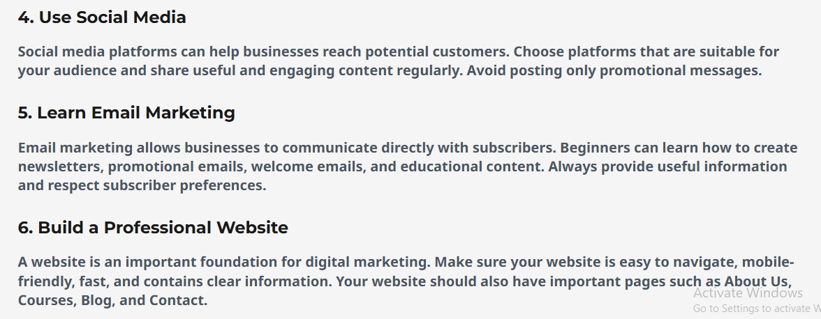
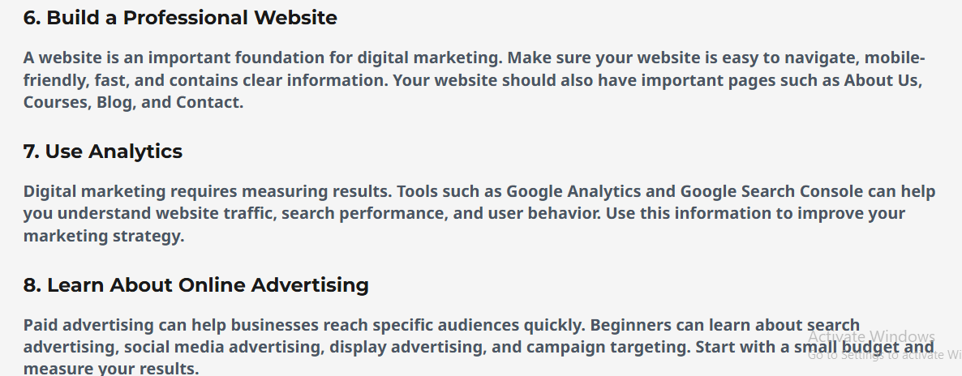
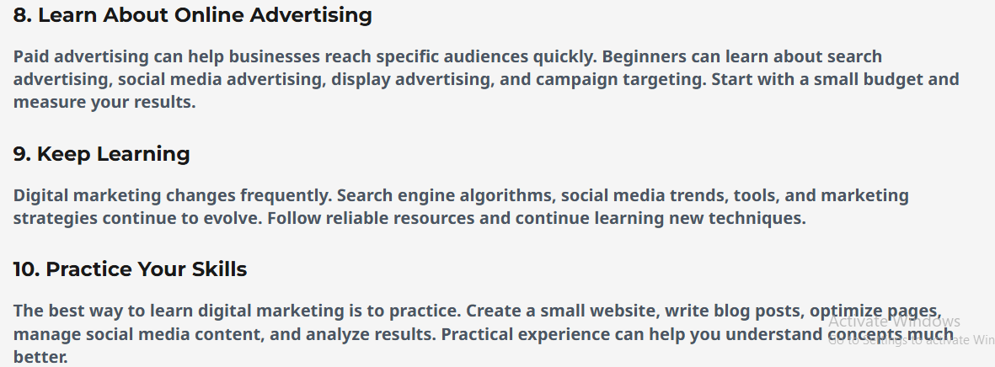
How to Start Learning Web Development
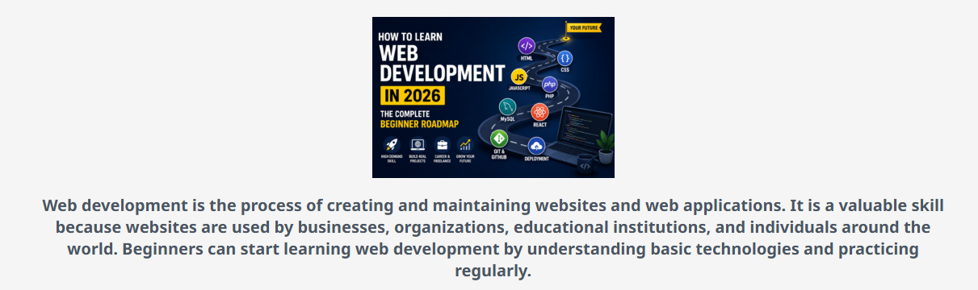
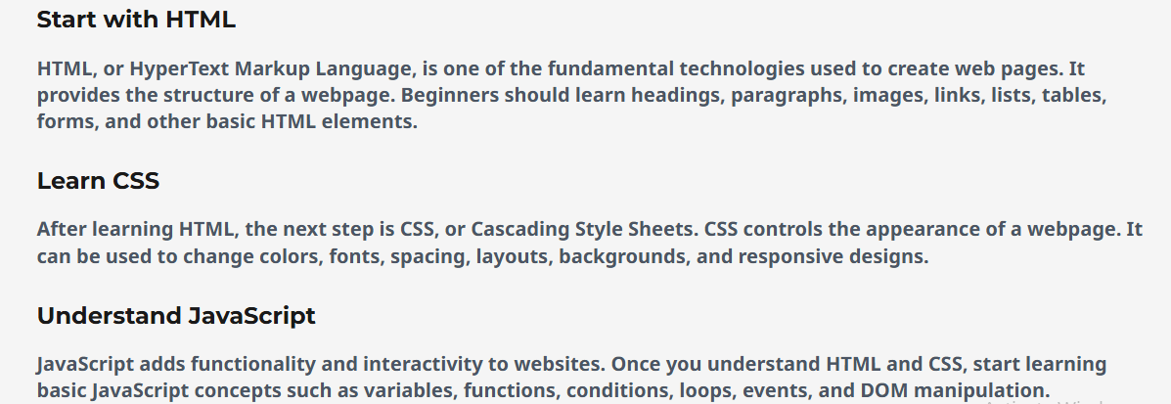
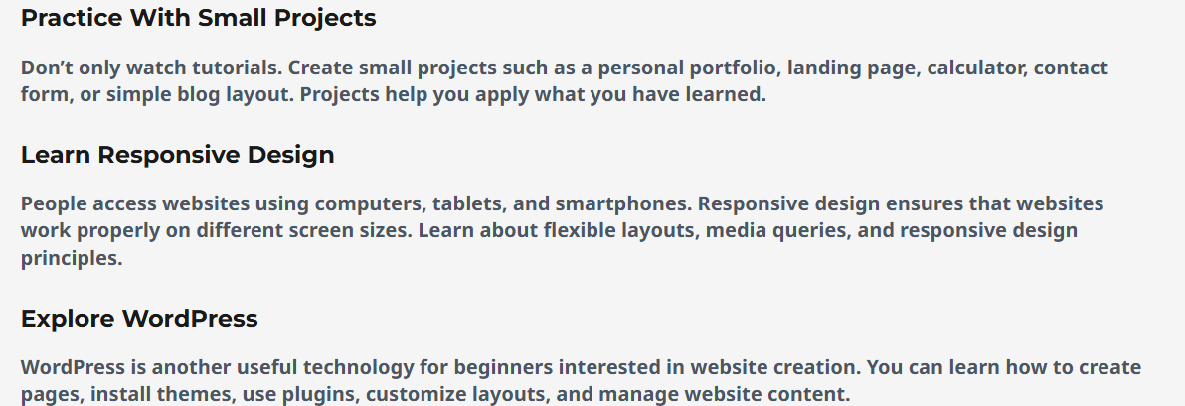
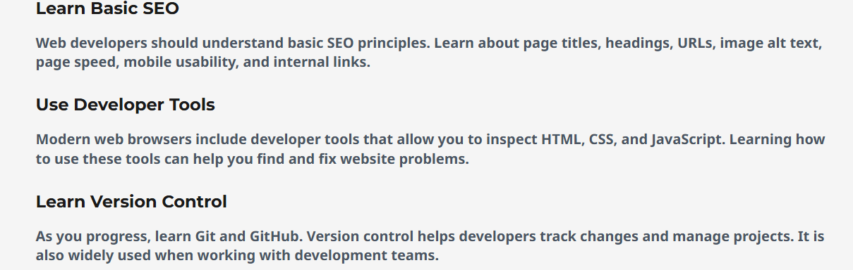
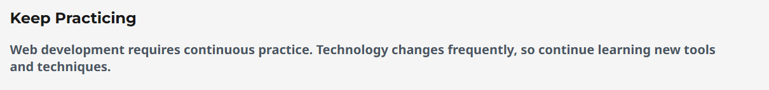
Why Online Learning Is the Future
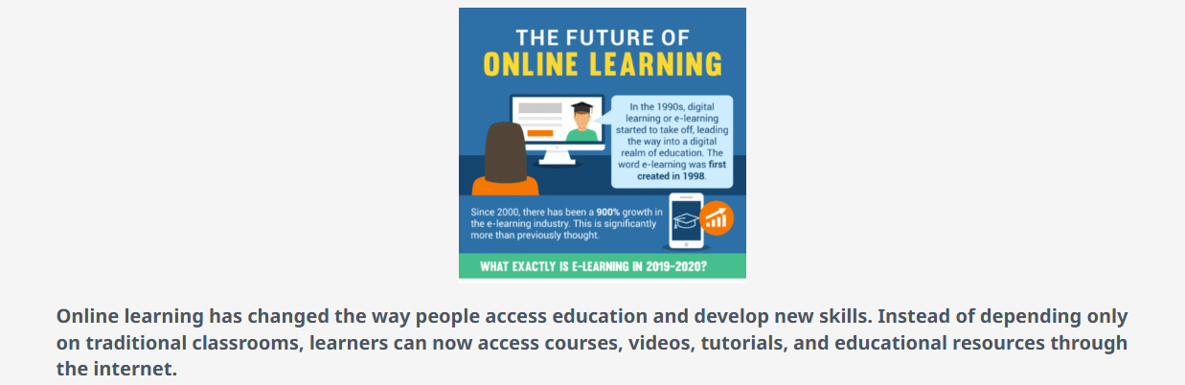
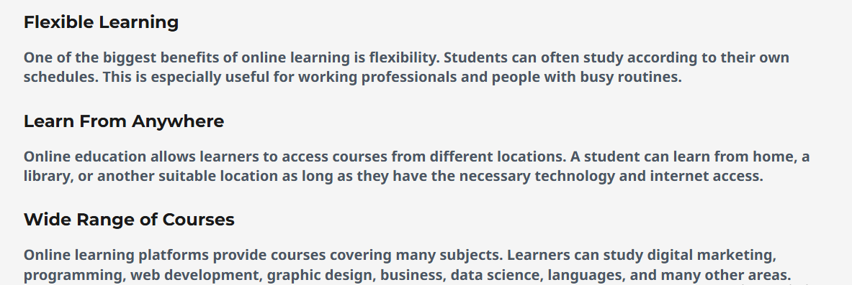
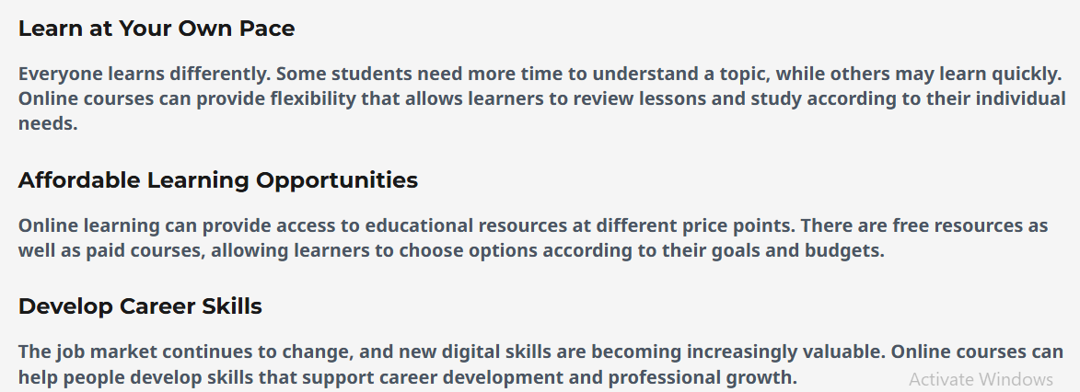
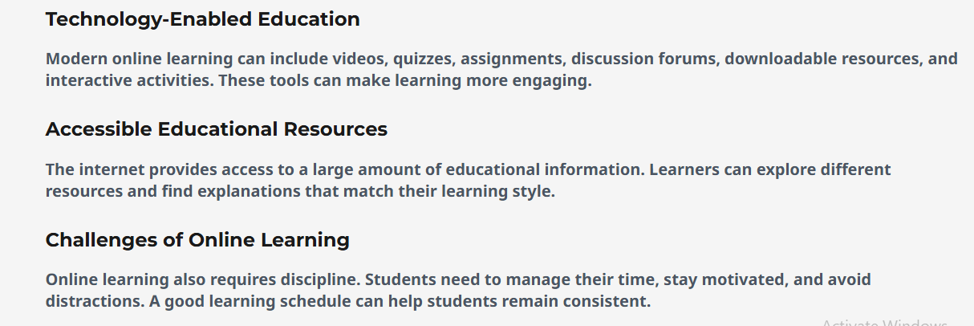

Start Learning Today

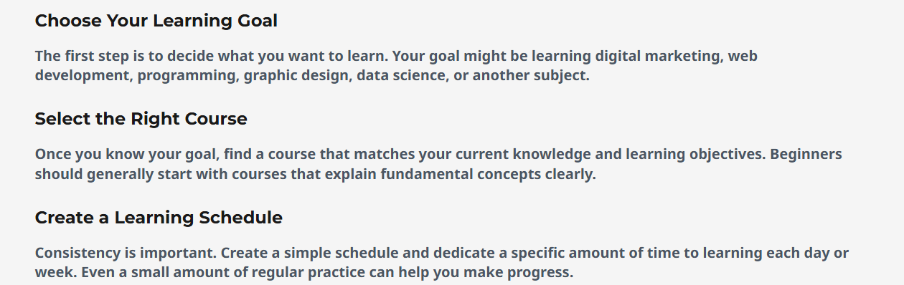
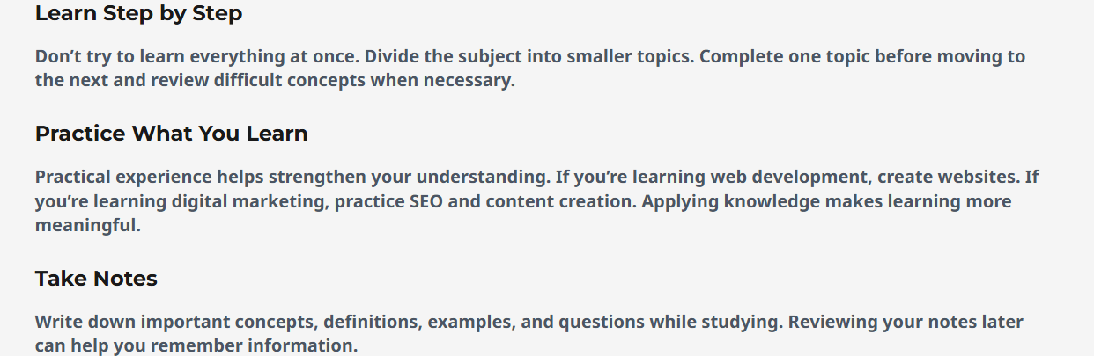
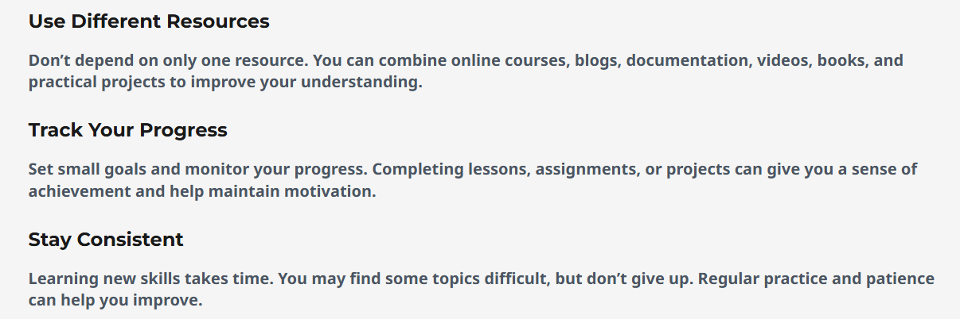
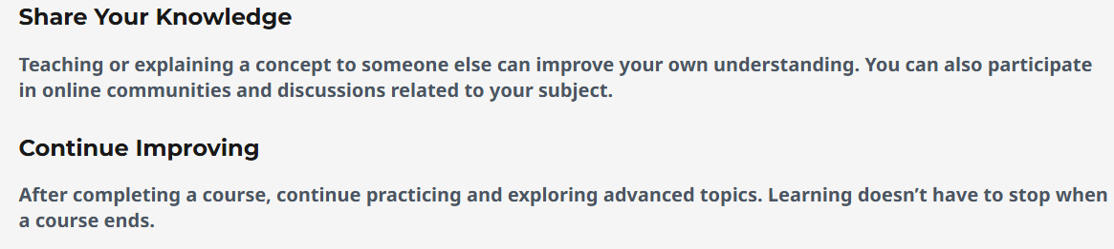
Website Audit
Problem Identified | Solution Implemented
Poor SEO optimization | Improved SEO titles and descriptions
Missing image ALT text | Added descriptive ALT text
Weak internal linking | Added relevant internal links
Long URLs | Optimized page slugs
Limited content | Added useful website content
Indexing issues | Submitted sitemap and inspected URLs
Poor navigation | Improved menu structure

Results and Outcomes
• Developed a complete e-learning website.
• Created multiple website pages.
• Implemented on-page SEO.
• Configured Yoast SEO.
• Worked with Google Search Console.
• Created Google Ads campaigns.
• Added course and educational content.
• Improved website structure and navigation.
Challenges Faced
• WordPress configuration issues
• Elementor editing problems
• Sitemap/indexing issues
• SEO optimization problems
• Website navigation issues
• Google Ads setup challenges
Learning Outcomes
• WordPress website development
• Elementor
• SEO
• Yoast SEO
• Google Search Console
• Google Ads
• Keyword research
• Content marketing
• Website auditing
• Basic digital marketing strategy
• Website analytics

